Student Course Selection-Log in
A Login ID and a temporary Password will be provided to you when you activate your Student Portal account. Enter or click on the hyperlink for MyEdBC Student Portal: https://www.myeducation.gov.bc.ca/aspen/logon.do
When you arrive at the home page you will see the log in window. Follow the directions below to complete the account activation:
- Enter your Login ID and temporary Password
- Click Log On
- You will be prompted to change your password. ‘Current Password’ is the temporary Password you were provided. Enter a ‘New Password’ and ‘Confirm New Password’. Password requirements are displayed behind the red warning message.
- You will be prompted to confirm your email address and enter your Security Preferences by choosing a security question and answer that you will remember. This will allow you to use the ‘Forgot my Password’ function on the logon page, should you need to reset your password.
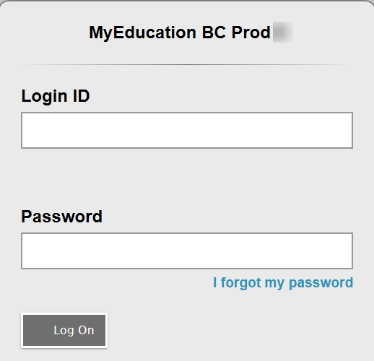

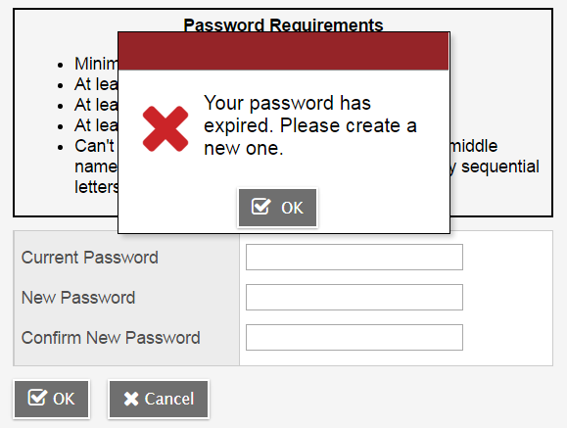

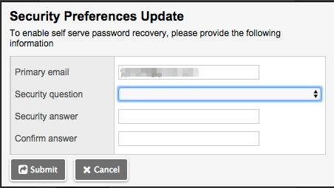

Student Course Selection-Account Preferences

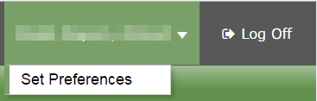
Preferences-After you have logged in, you can make changes to your preferences by selecting the drop-down arrow beside your name and ‘Set Preferences’ in the top right of the screen.

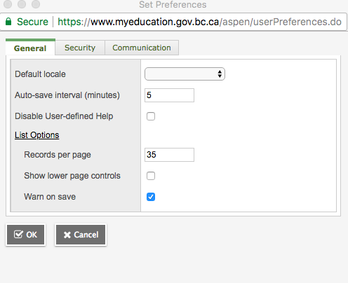
General- sets your ‘auto-save’ interval and records per page view.
Security-show primary email address, and your security question and answer
Communication-regulates number of forum posts per page.
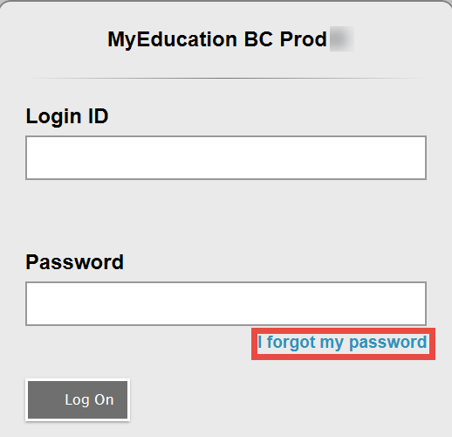
Password Recovery-If you forget your MyEdBC Portal Password, you can click the ‘I forgot my password’ link on the login screen and an email will be sent to you with a new temporary password.

Student Course Selection-Select Courses
- Click on the MyInfo Top Tab (TT). Then go to the Requests Side Tab (ST). You will see the following screen:
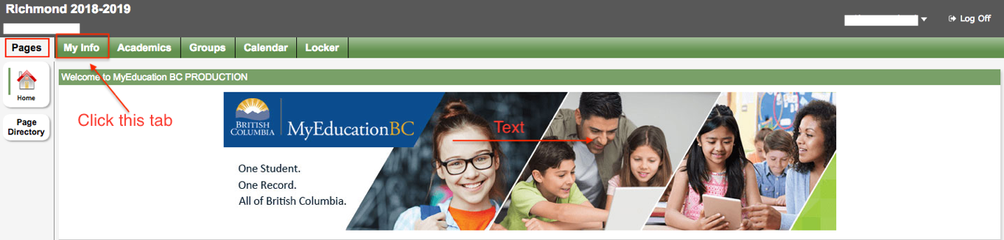
This window has three different sections:
Instructions- Here you will find an overview of the courses and any notes regarding course selections for your grade. These will be similar to the instructions on your course planning sheet.
Requests- Primary requests are your course requests for the next school year (2020-2021). By clicking on the Select button on the bottom of your Instructions window you can view the course options for your grade level.
Notes for Counsellor- leave blank

- Click on the Select button on the bottom of the instructions window. This will open a pop-up window that has the available course selections for your grade.
- Courses are sorted alphabetically by department
- You can scroll through the course options by using the tab at the top of the page
- You can sort your courses by description by clicking on the Course Description header
- Select your course choices by clicking on the check box beside the course. When you are done click OK
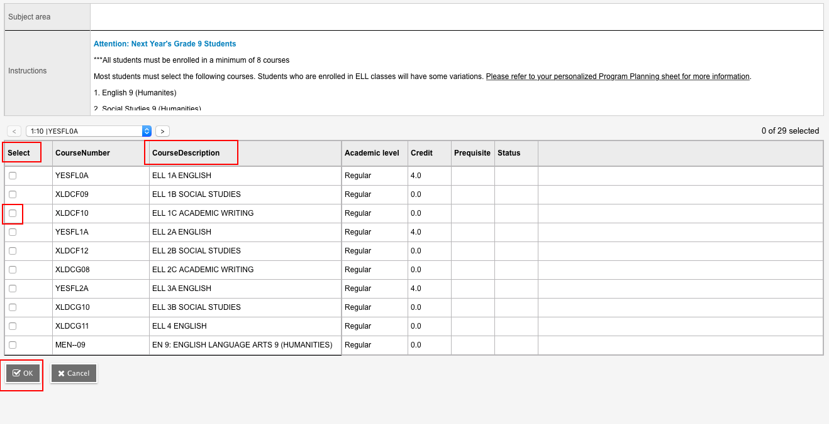

- When you have selected courses, you will see them in the Primary Requests window.
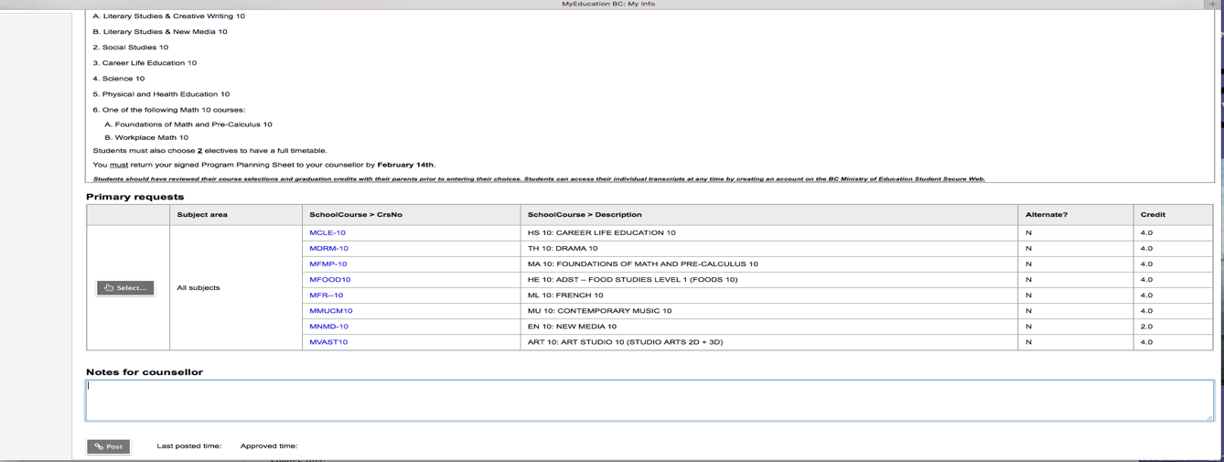

Note: Carefully check your course requests before closing your browser. These are the requests that will be submitted as your course requests for next year.

- If you see an error, click the Select button again and make your corrections.
- When all of your course selections are correct hit the POST button on the bottom of the window.

Note: Failure to POST your course selections will impact the course registration totals and may cause a course to be dropped due to lack of enrollment. Each time you make a change after posting, you must hit post again for the system to pick up the changes.

